**Semi-Automated Magazine Layout Using Content-based Image Features**

|  |  |  |
| --- | --- | --- |
| Mikko Kuhna  Aalto University  Dept. of Media Technology  Otaniementie 17  Espoo, Finland mikko.kuhna@aalto.fi | Ida-Maria Kivelä  Aalto University  Dept. of Media Technology  Otaniementie 17  Espoo, Finland ida-maria.kivela@aalto.fi | Pirkko Oittinen  Aalto University  Dept. of Media Technology  Otaniementie 17  Espoo, Finland pirkko.oittinen@aalto.fi |

# ABSTRACT

We present a system for automating magazine layout process and data on its performance in a user evaluation test. The purpose of the study is to find the feasibility of the key system variables on the end-user. This semi-automatic system is based on content-based image feature algorithms to automate the layout process. The image related automation includes image cropping, overlaying text on top of images, image color palette creation, and image alignment. The algorithms rely on principles of photography and are used here together in the context of graphic design. For example the rule-of-space and leading line concepts can be extended to layout contexts for improved alignment of text and images. The computation is based on automatic analysis, such as face detection, color saliency, and textureness. We used the automation to create a functional prototype, an iPad magazine, using an open HTML5 eBook framework, which relies on CSS3 media queries for the layout adaptation. User experiments (40 participants) were conducted where the system was compared against two commercial iPad magazine systems in terms of overall usability with emphasis on visual aspects. Questionnaires and free commenting was used in a task-based usage scenario. The experiments were video recorded and the user comments were transcribed and coded into attributes. Usability results mixed with qualitative observation are reported. Results show that usability, readability and visuality are important to the users. Our system was considered more usable than the other two systems with some of the defining aspects being simplicity in terms of usability, subjective readability and visual clarity.

# Categories and Subject Descriptors

H.5.1 [**Multimedia Information Systems**]: Evaluation / methodology; I.4.7 [**Feature Measurement**]: Features— *color, face detection, perspective lines, saliency*; I.7.2 [**Document Preparation**]: Desktop publishing, Photocomposition / typesetting; I.7.4 [**Electronic Publishing**]

|  |
| --- |
| Permission to make digital or hard copies of all or part of this work for personal or classroom use is granted without fee provided that copies are not made or distributed for profit or commercial advantage and that copies bear this notice and the full citation on the first page. To copy otherwise, to republish, to post on servers or to redistribute to lists, requires prior specific permission and/or a fee.  *MM’12,* October 29–November 2, 2012, Nara, Japan.  Copyright 2012 ACM 978-1-4503-1089-5/12/10 ...$15.00. |

General Terms

Algorithms, Design, Experimentation

# Keywords

Page layout, image feature, responsive design, layout adaptation, user evaluation

# INTRODUCTION

Magazine publishing is at a turning point. Print publishing is still the norm, but publishers have started to adopt digital tablets as a new platform. Other publication types have been supporting digital platforms for a long time. The relatively slow publication intervals of magazines defy the business logic of the web. The transformation of magazines has been slowed down, among other things, by high demands for usability, readability and visual appeal. So they cannot really be compared to Web publishing, which is fast-paced and typically free of charge. There are paid digital publication types in the form of eBooks, and personal readers like Amazon Kindle have become popular. However, the problem is that those platforms do not support the visual appearance of magazines. A magazine loses its selling point if it loses its high-quality visual appeal.

Tablets provide a digital platform that makes the highquality visual appearance of a magazine possible. The form factor of most tablets is also very similar to current print formats. Computer operating systems enforce multitasking with multiple windows and menu bars etc., whereas a tablet is more of a single-task device. Tablet operating systems force the active application to use almost 100 % of the display. Touch-based interaction also resembles the natural browsing experience of a magazine.

Current tablet magazines (typically made with e.g. Woodwing Tablet Publishing or Adobe Digital Publishing) are for the most part PDF-style print replicas, or manually laid-out print variants with some added interactive elements. Tablet magazines are rendered as layered images in a desktop publishing software. As a result, text is rendered as bitmap images and is not selectable by the user. Another shortcoming is that a magazine can take up to hundreds of megabytes per issue while supporting often only one orientation mode.

In this work the layout automation is based on contentbased image features, and the content is displayed using HTML5, CSS3 and JavaScript, utilizing a design concept called responsive design. Responsive design [23] essentially means that a web site is crafted to use W3C CSS3 media queries[1] in order to adapt the layout to the viewing environment. A similar approach is used in adaptive grid-based layout overall, where responsive design only states that CSS3 media queries are the technique used.

System development and evaluation were accomplished as an industrial collaboration with a magazine publisher (Sanoma Magazines Finland[2]) and a technology supplier. The long-term focus is to automate tasks in the magazine publishing workflow to make cross-media publishing efficient. In this study we only test different orientation modes, but adaptation to completely different device form factors is currently studied. Our system is designed to be implemented in editorial systems or any authoring tools. The focus here is magazine publishing, but the system design can be modified for any types of publications where images are used as layout elements.

In this first stage of our system development we evaluate the performance of the content-based image feature algorithms and our first functional magazine prototype. Currently we are developing a magazine content model for handling content and related metadata. In the last stage we will develop the authoring tool and test it in an editorial office with professionals (project page[3]).

# BACKGROUND

## Adaptive layout

A grid-based layout is used in the print layout of newspapers and magazines. Many solutions have been presented to allow adaptation of layout to different screen sizes, such as the adaptive grid-based document layout [15] and its extension to dynamically aggregated documents [27]. These types of systems generally use grid-based layout templates and some flexibility in the templates is solved using layout constraints. The constraints are used for example so that the title element is constrained to begin at the top of the page and the font type is increased as long as the title element fits the page width. Images are treated as one element type in the layout, albeit with dimensions and perhaps some placement constraints.

Another approach is to process images to fit the layout constraints. Methods such as image retargeting [28] and seam carving [2] can be used for scaling images without losing the important objects in the image. Methods have also been presented for retargeting other visual media types such as web pages [17] and other documents [5]. For image-heavy publications, such as photo books, there are also automation solutions that utilize image features [26].

Most systems have focused on paginating the content and also separating the content and the presentation. XML or HTML is generally used to specify the content and CSS is used for presentation. HTML is often seen as too limiting for paginated content [27] although with the new features in CSS3, pagination has become more accessible [25].

Our approach uses a responsive web design framework for the layout templates for different screen sizes. The framework is also based on a grid-based approach. The images are automatically cropped to fit the layout constraints based on

**Magazine App**

**)**

**e.g. Baker or web app**

**(**

**Stylesheet**

**template**

**(LESS)**

**Document**

**template**

**(HAML)**

**Authoring tool**

**Document model**

**(**

**XML**

**)**

**Document**

**HTML**

**(**

**5)**

**Stylesheet**

**(**

**CSS**

**3)**

**Processed images**

**)**

**(**

**JPEG, PNG**

**Images**

**(**

**JPEG, PNG**

**)**

**Image feature**

**algorithms**

**Figure 1: System overview diagram.**

image importance. Unlike previous systems, our system is designed especially for magazine style image heavy content and does not rely on pagination.

## Image features

Photographic principles [13] such as the rule-of-thirds have been used in many studies. Other photographic concepts include for instance the use of shallow depth-of-field or color contrast to separate the main subject from the background. These principles are used for example in photo quality assessment [16, 29], computational aesthetics [10], photo and video quality assessment [22], photography systems [4, 9], photobook systems [26] and web image search [12].

In this study, photographic principles are utilized in the graphic design context by employing content-based image features. The purpose is to automate image related layout tasks. For example the rule-of-space (head room or lead room) concept is used to apply a sense of movement in the photograph. A photo is framed so that there is more empty space towards the side of the photo where the main object is facing. This is often also true in layout. An image is placed so that there is more empty room towards the side of the page where the main object in the image is facing. A concept called leading lines is used similarly for photos with a clear perspective.

# LAYOUT SYSTEM

## Overview

A semi-automatic system for creating layouts for magazine articles (incl. text, images, captions, headings etc.) was created. Its novelty lies in utilizing content-based image feature algorithms for the layout of high-quality visual content (here, magazine articles) with the aid of responsive web design techniques to adapt content to different devices and orientations. The layout templates are based on Laker[4]templates that use open web frameworks (e.g. LESS[5] and jQuery[6]). Our focus is on tablets, but adaptation to smaller mobile and desktop browsing conditions may also be done.

An overview of the system is illustrated in Figure 1. The content is inserted into the system with an authoring tool. Document template (i.e. article type) and stylesheet templates are selected by the user. Images added into the authoring tool are processed using the developed image feature algorithms. In the end the document, the stylesheet and the processed images are composed into a web page and presented in the magazine app. The image feature algorithms

**Image Combined Image Image**

**palette**

**center of**

**importance**

**face**

**orientation**

**color**

**perspective**

**image feature**

**maps**

**feature**

**maps**

**feature**

**values**

**feature**

**algorithms**

**image**

**cropping**

**article**

**color**

**text**

**overlaying**

**image**

**alignment**

**contents**

**page**

**edge**

**map**

**textureness**

**map**

**skin color**

**map**

**color saliency**

**map**

**face**

**map**

**salient color**

**map**

**importance**

**map**

**Figure 2: Image feature algorithms and corresponding computational approaches.**

form the automatic part of the system. For non-image layout operations the system relies on the defined templates.

## Image feature algorithms

Content-based image feature algorithms are used to automate the layout creation. The focus is on automating image-related tasks in the creation of an adaptive layout. Figure 2 illustrates the image feature algorithms and the computational features used. The features are results of image analysis and are grouped here in maps, combined maps and values. The algorithms were implemented in the MATLAB environment. The automated image process for one example image is illustrated in Figure 3 (next page).

Table 1 gives a summary of the feature maps and their values. A more detailed discussion of the algorithms is beyond the scope of this paper. This is because many of the computations are content-specific and have so far only be tested for images of a few magazines. These principles should be generalizable for most kinds of editorial publications and our future work includes tuning the algorithms for different publications and adding more automated tasks for specific image types (e.g. food photography and interior design).

### Article color

Colors are important for both visual experience and brand management [8]. In magazines it is typical to select for each article an identifying color, which is then used in different elements, such as titles and pull quotes. Our approach creates an image-based color palette considering all the images in the article. Based on this palette a single article color is chosen.

The computation of an article color is illustrated in Figure 4. Color palettes of are created for all images belonging to an article. The best article color candidate is selected for each image based on its recurrence in other color palettes and color difference to the representative colors of the publication. One future approach could be to include some kind of text-based semantic content analysis [14].

### Text overlaying

Interaction of text and other elements is a common chal**Table 1: Feature maps and values.**

|  |  |
| --- | --- |
|  | **Feature maps** |
| Color saliency | Color difference relative to the average color of an image. [1] |
| Skin color | Color difference to a selected skin color value. |
| Edge | Average of the horizontal and vertical Sobel filtered R, G and B color channels. |
| Textureness | Cross-bilateral filtered L* channel. Basically it is the remainder of an edge-preserving filter. [3] |
| Face | OpenCV face detection algorithm. [30] |
|  | **Combined feature maps** |
| Salient color | Weighted sum of the color saliency, skin color and face maps. |
| Importance | Weighted sum of the color saliency, skin color, edge, textureness and face maps. |
|  | **Feature values** |
| Color palette | Derived from the salient color map by first thresholding the map into salient and non-salient regions. The a*- and b*-channels of the salient and non-salient regions are then clustered separately with k-means clustering. The seven-color palette is the average RGB color of the first four clusters of the salient region and the first three clusters of the non-salient region. |
| Center of importance | Center mass coordinate of the importance map. |
| Face orientation | Derived from non-frontal face detection and whether there are more faces detected with leftor right-oriented pose. |
| Perspective | Based on Hough transform, which looks for continuing lines. The horizontal coordinate of the perspective point is analyzed. [11] |

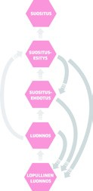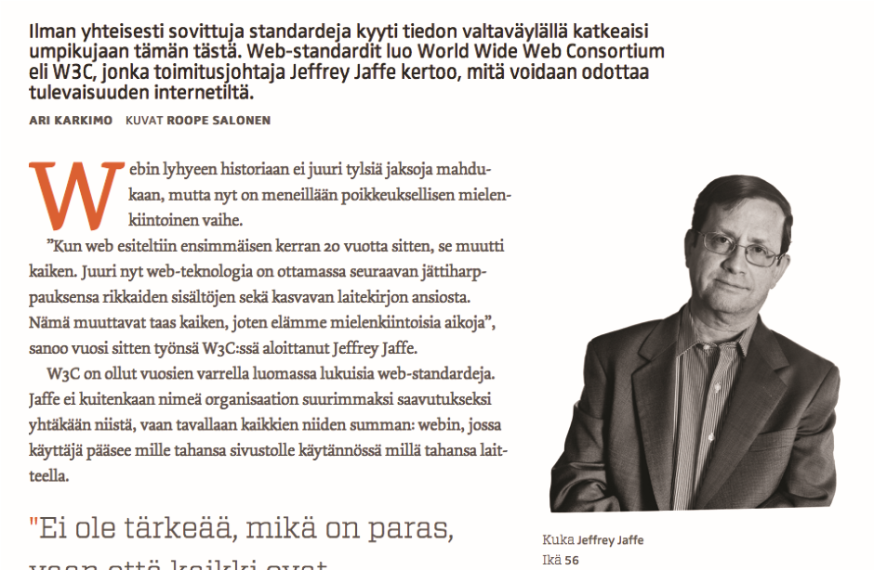

**color palette**

**for each image**

**representative**

**colors**

**one color for**

**each image**

**article**

**color**

**Figure 4: Article color is selected based on the color palettes of all images in an article. The bottom image is an example of how the article color is used in typographic layout elements.**

|  |
| --- |
| **Figure 3: An example of the automated process for the main image of an image heavy article. In this example the face detection algorithm did not find a face and therefore the skin color map has a greater weight. Skin color, color saliency, textureness and edge maps are combined to form an importance map, which is used to create the cover image for both orientation modes and thumbnails for the contents page and navigation bar. Skin color, color saliency and textureness maps are also used for determining salient regions, which are used** |

**in the color palette processing.**

lenge in layout creation [18]. Articles need to combine text and graphics in ways that connect them but do not harm the readability. The importance of images needs to be analyzed and text placed over the least important areas of the selected background image. Our approach is to use text overlaying in the generation of the cover page of image heavy articles (Figure 3).

The positioning of the title block is automatically computed from the importance map as the area with the lowest importance. The article color, black or white, is used as the title color. The color with the highest color difference to the area in the underlying image is selected. If there is too much texture variation in the area in the underlying image, a white, black, translucent white or translucent black box is added to the background to increase color contrast.

### Image cropping

It is challenging to create adaptive layouts without cropping images. Full-page images are common in magazines, producing a need to crop portrait images for a landscape layout and vice versa. Our approach uses the importance map to crop the image to make a thumbnail image for the contents page and navigation bar as well as full-page images for both orientation modes for the article cover page (Figure 3).

The image cropping is based on maximizing the corresponding area of the importance map. A summed area table is used in the computation. The importance map is a weighted sum of color saliency, skin color, edge, textureness and face maps. The face map is weighted the highest, because faces, if present, generally are the main objects in images. If faces are not found, the skin color map is given greater weight in case there are undetected human objects in the image. The color saliency map is designed to find non-human main objects whereas edge and texture maps are designed to find the main objects in shallow depth-of-field images.

### Contents page

Some magazine layout tasks can be completely automated with proper content metadata. Creating the magazine contents page is an example of such a task. Our approach is to create a landscape orientation preview image of the main image of each article using the same image cropping method (Figure 3). The article main image is determined in the authoring tool. The contents page then consists of an article list with a preview image and some text elements of each article. The image and text alignment is also automatically done based on the center of importance of the cropped image.

### Image alignment

Optimal image placement as a whole is a very high-level concept and difficult to compute. Nevertheless, some simple rules can be applied to select, for example, whether an image should be aligned left or right in relation to the text. Our approach is based on the rule-of-space and leading line concepts. Rule-of-space is used to apply a sense of movement, for example by adding whitespace towards where a person is looking or moving. The concept of leading line has the

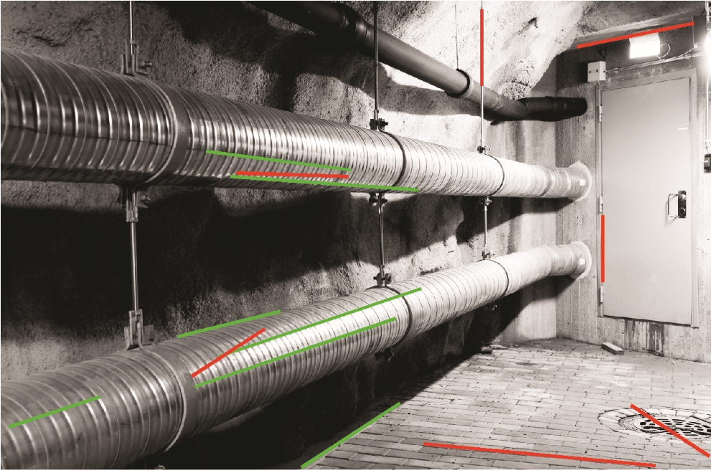

**Figure 5: An example analysis of an image with continuing perspective lines. Red and green lines indicating most relevant detected lines and green lines indicating lines that connect in a same perspective point. The perspective point in this image is located right from the center and the image should therefore be left-aligned.**

same goal, but here perspective lines are used to guide the focus of the viewer.

Image alignment computation is based on the center of importance, face orientation and perspective feature values. Face orientation, given the greatest weight, tells whether more faces are facing left or right. The center of importance works similarly for non-face objects. The perspective feature value is used for the leading line concept. A value for left alignment is given if the face orientation is faced to the right, if the center of importance is located left from the center and if the perspective point is located right from the center. The reverse is true for right alignment. An example of the leading line and the perspective analysis is shown in Figure 5.

# TEST SETUP

A test magazine was created with the designed layout system using a published print magazine (Tietokone[7]) as the material for full experimentation of the performance of the system. It was selected because at that time it was one of the few Finnish language magazines with a commercial tablet version available for comparison. Images in the magazine are typical magazine feature images and technical product images.

As the commercial solution was available for the Apple iPad platform, it was chosen as the evaluation platform. The magazine was created with the Baker eBook Framework[8] for iPad, but the content is extendable to any platform with HTML5 support.

The magazine is fully operational in modern browsers, but the eBook framework enables some interactive and performance features. A native application can be created using the platform. The magazines pages can be defined using the HPub specification[9].

The interactive features in the framework were related to **Table 2: Magazine solution comparison.**

|  |  |  |  |
| --- | --- | --- | --- |
|  | **Manual** | **Automatic** | **Responsive** |
|  | **Layout** | |  |
| **Layout style** | Magazine  style | Newspaper  style | Magazine  style |
| **Pagination** | Paged | Paged | Continuous |
| **Orientation modes** | Vertical | Both | Both |
| **Columns** | Mainly two-column | Mainly two-column | Mainly one-column |
| **Fullscreen images with overlaid text** | Yes | No | Yes |
| **Use of colors** | Article color | Section color | Article color |
|  | **Authoring** | |  |
| **Image processing** | Manual | Downscaling | Automatic, contentdependent |
| **Article color** | Automatic |
| **Overlaid text placement** | Unsupported |
| **Image placement** | Automatic |
| **Contents page** | Automatic, prioritybased |
|  | **Navigation** | |  |
| **Between**  **articles** | Horizontal swipe | Horizontal swipe | Horizontal swipe |
| **Within articles** | Vertical swipe | Vertical swipe | Vertical swipe |
| **Navigation bar** | Yes | Yes, sectionbased | Yes |
| **Navigation levels** | Articles | Sections and  articles | Articles |
|  | **Contents page** | |  |
| **Style** | List | Collection | List |
| **Information** | Only title | Text and images | Text and images |
|  | **Interactive features** | |  |
| **Customizable font size** | No | Yes | No, not implemented in this version |
| **Image**  **gallery** | Yes | Yes |
| **Interactive images** | Yes | No |
| **Scrolling frames** | Yes | No |

navigation. Horizontal swipe was used to navigate between the articles. An interactive navigation bar was included and accessible to the user by double tapping the display. Otherwise the magazine was intentionally left without other interactive features to get more feedback related to the visual aspects.

Our responsive magazine prototype was compared against two other commercially available magazine solutions. Table 2 summarizes the main differences between the systems. The first solution is a retail version of the magazine sold in the Apple App Store. It was made by a graphic design company contracted by the publisher and manually laid-out in a desktop publishing software with Woodwing publishing tools[10]. The automatic system is a commercial **Figure 6: Layout comparison of the magazine solutions with an image heavy article example.**

cross-platform application (Anygraaf AnyReader[11]) that adapts the layout to any screen resolution. It was originally made for newspaper content, but modified for this experiment to have better support for magazine content. It was designed to be connected to an editorial system and the adaptation was carried out only based on the display pixel dimensions.

The developed prototype magazine differs from typical currently existing digital magazines in many ways. In our prototype the pages are not paginated, which naturally affects the layout process. However, usually the article cover is the most demanding in terms of layout and it can be designed as a page with responsive design. Non-paginated and mostly one-column articles have a simple structure, known to produce a better reading experience in digital environments [6, 21]. We included different types of magazine layout solutions in our test so that the qualitative evaluations would reflect broad design choices and could be analyzed to produce guidelines for developing digital magazines.

## Layout style

The layout style differs in many ways between the solutions (Figure 6 and Figure 7). The automatic solution uses a grid-based layout that resembles a newspaper layout, whereas the manual and responsive solutions aim to mimic the print magazine layout. The manual and automatic solutions paginate the articles, whereas the responsive solution relies on a web-style continuous layout. The manual solution supports only the portrait orientation mode, whereas the other solutions adapt the layout to both modes.

The responsive solution uses mainly a one-column layout

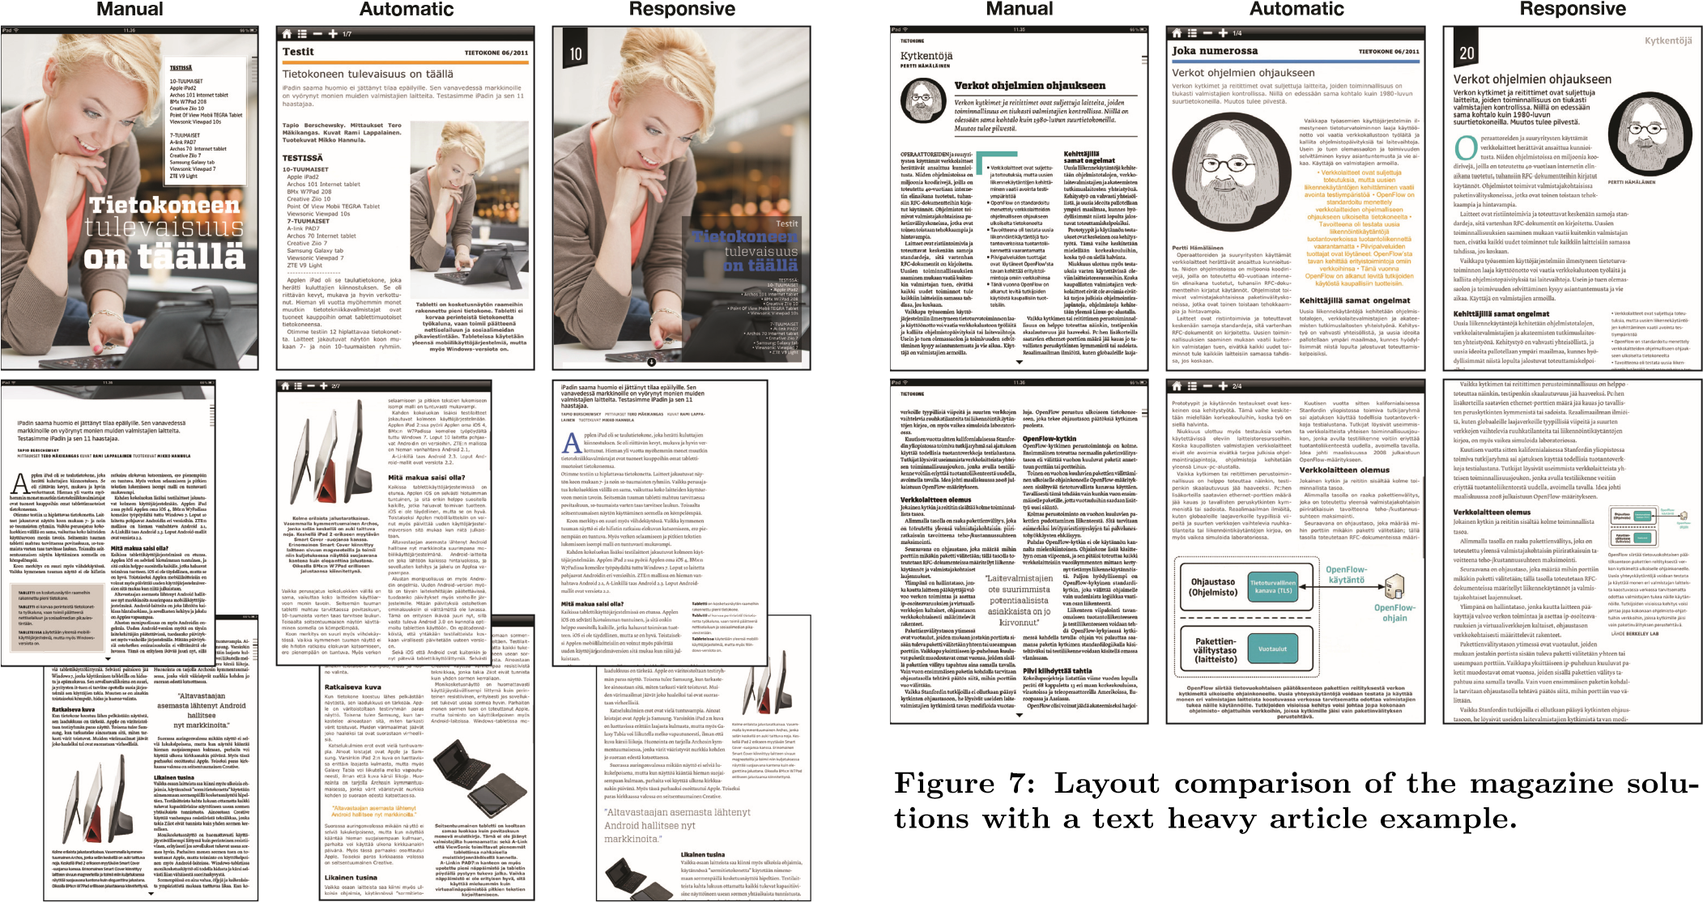for article text, whereas the manual and automatic solutions use mainly two columns. The automatic solution lacks the magazine style fullscreen images with overlapping text. All the solutions have colors in the layout. The manual solution uses one or multiple colors for each article, the responsive solution uses one color for each article, whereas the automatic solution uses one color for each section.

## Authoring

The layout for the manual system is made with a desktop publishing software and the layout is non-adaptable. Therefore all the authoring tasks are manual. The automatic solution is developed together with an editorial system and it automatically creates the layout for different display dimensions. Images are downscaled to fit the layout constraints and a default color is assigned for different sections. The system does not support overlaid text, and image placement is automatic, whereas the contents page is automatically created using the article priority metadata.

## Navigation

The navigation approaches are very similar between the solutions. Navigation between articles is carried out with horizontal swiping and navigation within articles is carried out with vertical swiping. However, there are differences in navigation between the solutions especially due to the differences in pagination and navigation levels.

All the solutions have somewhat different navigation bars. The navigation bar is opened in the manual solution by tapping the bottom part of the display and in the responsive solution by double tapping any part of the display. In the automatic solution the navigation bar is shown each time the user navigates to a new page as well as by tapping the display.

The automatic solution differs the most from the other solutions in terms of navigation as it has two navigation levels. The first level consists of section pages, where articles

**A.1.1**

**P.1**

**A.1.2**

**P.1**

**A.1.1**

**P.2**

**A.1.1**

**P.3**

**A.1.2**

**P.2**

**S.1**

**P.1**

**...**

**S.2**

**P.1**

**A.2.1**

**P.1**

**A.2.2**

**P.1**

**A.2.1**

**P.2**

**A.2.1**

**P.3**

**S.1**

**P.2**

**CP**

**Automatic**

**A.1**

**P.1**

**A.2**

**P.1**

**A.1**

**P.2**

**A.1**

**P.3**

**A.2**

**P.2**

**CP**

**...**

**C**

**Manual**

**A.1**

**A.2**

**CP**

**...**

**Responsive**

**Figure 8: Navigation in the magazine solutions. C = Cover, CP = Contents page, A = Article, P = Page and S = Section.**

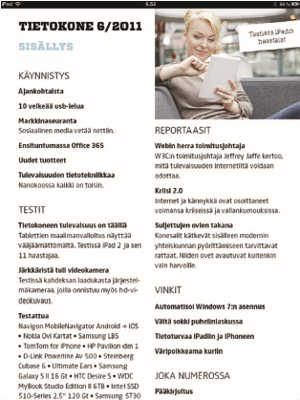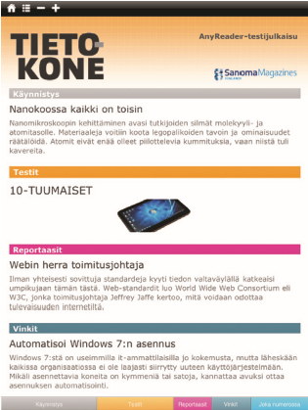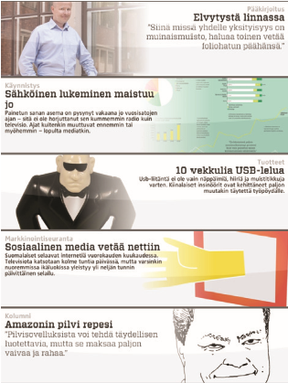

**Manual**

**Automatic**

**Responsive**

**Figure 9: Layout comparison of the magazine solutions with a contents page example.**

are laid out in a newspaper style layout. The section pages show only a sample of the article (a title, some text and sometimes an image). A greater area is given to higher priority articles. By tapping an article, the user navigates to the corresponding article in the article level and by swiping upwards in the article level, the user navigates back to the corresponding section page. Figure 8 illustrates the differences in navigation between the solutions.

## Contents page

All the solutions have a contents page as the first page of the magazine (the retail solution has a cover page before the contents page). The contents pages are shown in Figure 9. The manual solution only lists the article titles in sections, whereas the responsive solution lists the articles in reading order by showing an image and text of the article. The automatic solution has a section-based contents page with images and text, but it only shows a few highest priority articles and uses the section pages as more detailed contents pages.

## Interactive features

The manual and automatic solutions have some interactive features that were not implemented in this version of the responsive solution. The automatic solution includes a feature to alter the text size. Both the manual and automatic solutions have an image gallery. In addition to the gallery, the manual solution has different types of interactive images, which are activated by tapping the image (to enlarge, show a caption or detailed information, etc.). The manual system also has scrolling frames inside the paginated pages. Those are used both for text blocks and images.

# USER EVALUATION

We performed evaluations of the magazine solutions that included usability, covering also readability, and visual aspects. Our 40 participants were undergraduate and postgraduate students in various engineering disciplines ranging from computer science to electrical engineering and chemical engineering. Their mean age was 25 years (*SD* = 2). The majority (64%) had used a tablet computer but mainly for other purposes than reading magazines (28%). Only a few (10%) owned a tablet.

Each participant interacted with articles from a single magazine issue using two of the three magazine solutions (manual or automatic solution and our responsive solution) in a task-based usage scenario. Using one solution after the other (the order was counterbalanced across four participant groups), the participants were instructed to first browse at least 10 of the 22 articles and then read one article more thoroughly.

After the interaction period of roughly 10 minutes of navigating and reading the magazine on the first solution, the participants answered the system usability scale (SUS) questionnaire [7]. It was filled only for the first solution interacted with, to avoid priming effects. The SUS questionnaire was scored according to the two-factor structure [20].

Next, the participant moved onto the second solution and browsed at least 10 articles for 5 minutes in total. The experimenter then prompted the participant to pick four views where they had something to comment about the layout in comparison to the previous solution. These views were recorded as screenshots and will enable the use of computational layout metrics in the future.

A layout-related questionnaire with a 7-point Likert scale was filled for each screenshot. The questions were based on the tools developed for assessing visual aesthetics [24, 19], but extended here with questions covering the use of images, font type and readability. There were two types of questions in the layout questionnaire. The first type of questions included *”fully agree”* (positive) or *”fully disagree”* (negative) types of statements and the second type of questions included *”too little”* (negative), *”neutral”* (zero) or *”too much”* (positive) types of statements. The questionnaire statements are shown together with the average scores in Table 3 (next page).

The experiments were video recorded and participants were also asked to comment on each screenshot and the solution overall. The user comments were transcribed and coded to attributes using the ATLAS.ti software[12]. The attributes were selected based on the verbal user comments, where the context implied if the attribute was considered positive or negative.

|  |  |  |  |  |  |  |  |  |  |  |  |  |  |  |  |  |  |  |  |  |  |  |  |  |  |  |  |  |  |  |  |  |  |  |  |  |  |  |  |  |  |  |  |  |  |  |  |  |  |  |  |  |  |  |  |  |  |  |  |  |  |  |  |  |  |  |  |  |  |  |  |  |  |  |  |  |  |  |  |  |  |  |  |  |  |  |  |  |  |  |  |  |  |  |  |  |  |  |
| --- | --- | --- | --- | --- | --- | --- | --- | --- | --- | --- | --- | --- | --- | --- | --- | --- | --- | --- | --- | --- | --- | --- | --- | --- | --- | --- | --- | --- | --- | --- | --- | --- | --- | --- | --- | --- | --- | --- | --- | --- | --- | --- | --- | --- | --- | --- | --- | --- | --- | --- | --- | --- | --- | --- | --- | --- | --- | --- | --- | --- | --- | --- | --- | --- | --- | --- | --- | --- | --- | --- | --- | --- | --- | --- | --- | --- | --- | --- | --- | --- | --- | --- | --- | --- | --- | --- | --- | --- | --- | --- | --- | --- | --- | --- | --- | --- | --- | --- |
| **Table 3: Average layout questionnaire scores.** *CI*95% **in parenthesis.**   |  |  |  |  |  |  |  | | --- | --- | --- | --- | --- | --- | --- | |  |  |  |  | Manual vs. | Manual vs. | Automatic vs. | | Statements | Manual | Automatic | Responsive | Automatic | Responsive | Responsive | | *”fully disagree”* **(**−3**) or** *”fully agree”* **(**+3**)** | | |  |  |  |  | | I like the current section | -0.10 (0.57) | 0.45 (0.44) | 0.43 (0.40) |  |  |  | | Appearance is interesting | 0.58 (0.55) | 0.68 (0.53) | 0.98 (0.39) |  |  |  | | Appearance is clear | 0.00 (0.65) | 0.73 (0.62) | 1.30 (0.40) |  | *p < .*01 |  | | Colors are pleasing | 0.53 (0.53) | 0.43 (0.47) | 1.30 (0.36) |  | *p < .*05 | *p < .*01 | | Readability is good | 0.20 (0.54) | 0.30 (0.54) | 1.05 (0.41) |  | *p < .*05 | *p < .*05 | | Font type is good | 0.05 (0.50) | 0.03 (0.57) | 0.65 (0.41) |  | *p < .*10 | *p < .*10 | | *”too little”* **(**−3**),** *”neutral”* **(**±0**) or** *”too much”* **(**+3**)** | | |  |  |  |  | | Number of images | -0.02 (0.28) | 0.05 (0.31) | 0.05 (0.19) |  |  |  | | Amount of text | 0.33 (0.29) | -0.30 (0.33) | 0.08 (0.19) | *p < .*01 |  | *p < .*05 | | Size of images | 0.05 (0.31) | 0.23 (0.23) | -0.06 (0.23) |  |  | *p < .*10 | | Amount of whitespace | -0.55 (0.29) | 0.33 (0.29) | -0.05 (0.21) | *p < .*01 | *p < .*01 | *p < .*05 | |

The comments were coded so that if many participants used the same wording (e.g. clarity) or described a given detail of the solution in different words (e.g. navigation bar), it was used as an attribute. In all 33 different attributes were used in 837 instances, 423 of those being negative and 414 positive attributes. Of those, 402 were given to the responsive solution (it was commented by 20 participants), 210 for the automatic solution (10 participants) and 225 for the manual solution (10 participants).

# RESULTS

## Questionnaires

The SUS questionnaire resulted in no statistical differences between the different solutions. Clearly, device-related aspects were more important than the differences between solutions. Participants who regularly read newspapers or magazines gave lower SUS scores (*df* = 14, *F* = 2*.*18 and *p < .*05) and participants who did not own Apple devices gave higher scores (*df* = 14, *F* = 2*.*23 and *p < .*05).

As for the layout questionnaire (Table 3), for the *”fully disagree”*or *”fully agree”*types of statements statistically significant differences are observed in clarity of the layout, use of color, readability and font type. Our responsive solution received the highest scores for those statements. The statements related to overall appearance and interestingness resulted in no statistical significant differences between the three magazine manifestations.

For the *”too little”*, *”neutral”* or *”too much”* types of statements, statistically significant differences are observed in the amount of text, size of images and the amount of whitespace. The responsive solution received the most neutral scores for those statements. There are no statistically significant differences for the statement related to the number of images.

## Free comments

Overall, the attributes were divided almost evenly between positive (49*.*5%) and negative (50*.*5%). Of all the attributes given to the manual solution, 29*.*5% were positive, whereas 33% were positive for the automatic and 69% for the responsive solution. The attributes were categorized resulting in 11 different usability attributes, 6 readability attributes and 16 visuality attributes. The number of different types of attributes given to each solution is summarized in Table 4.

The most commonly mentioned attributes are shown in Figure 10 (next page). Clarity was the single most mentioned attribute. It was mostly used to describe the simplicity of a solution in a positive sense and complexity in a **Table 4: The number of negative (**−**) and positive (**+**) attributes mentioned for each magazine solution.**

|  |  |  |  |  |  |  |  |  |
| --- | --- | --- | --- | --- | --- | --- | --- | --- |
|  | Manual | | Automatic | | Responsive | | Total | |
| − | + | − | + | − | + | − | + |
| Usability | 84 | 24 | 64 | 19 | 33 | 122 | 181 | 165 |
| Readability | 34 | 6 | 33 | 10 | 33 | 61 | 100 | 77 |
| Visuality | 30 | 32 | 53 | 46 | 59 | 94 | 142 | 172 |
| Total | 148 | 62 | 150 | 75 | 125 | 277 | 423 | 414 |

negative sense. Some of the attributes like pagination, navigation, interaction, sections and image gallery show how the participants described different features of the solutions.

Continuous versus paged layout was one the differences between the solutions. Both the manual and automatic solutions relied on paged layout and received mostly negative pagination comments, whereas the responsive solution received only positive comments. The automatic solution used more complex navigation. It received noticeably more negative navigation comments than the other two solutions. Interaction was the most used negative attribute for the manual solution. The manual solution had many interactionrelated features that the other solutions did not have. Overall usability was the most used negative attribute for the automatic solution. Image gallery functionality was not implemented in this version of the responsive solution and it resulted image gallery being the most used negative attribute for the responsive solution.

Section pages was a feature that only the automatic solution had, and the solution received many comments related to it. The sections attribute for the automatic solution is distributed almost evenly between negative and positive.

# DISCUSSION

|  |
| --- |
| **Figure 10: The most used attributes for the manual, automatic and responsive solutions sorted by the total number of comments. Red bar = negative comments and Green bar = positive comments. U = Usability,** |

In this first stage of system development, we evaluated our functional prototype against commercial iPad magazines. Overall, the magazines covered many design choices (Table 2). As the magazines differ in many aspects (e.g. layout, navigation and interaction), the experimental setup was very challenging. The evaluation was user-centered, and **R = Readability and V = Visuality.**

thus well suited to reveal functional design solutions. A combination of usability and exploratory methods helped to uncover guidelines for making good digital magazines. There were shortcomings and advantages in all magazines. Had we just compared layout differences, other aspects related to design choices would not have been found.

Overall, the responsive magazine solution was evaluated better than the other magazine solutions in terms of usability and layout, although there were no statistical differences in the SUS scores. The layout questionnaire scores show that our responsive solution received better scores in terms of clarity, use of colors, readability and font type. Also, the amount of text and the amount of whitespace were considered better than in the other solutions. The SUS questionnaire did not reveal statistically significant differences between the systems, which might originate from these solutions being different in many ways and individual preferences leveling things out in such a general questionnaire.

The positive and negative attributes resulted in clear differences between the solutions (*chi*2 = 117*.*6, *df* = 2 and *p* =*< .*01). By comparing the different solutions (Table 2) and the attributes received by each solution (Figure 10), many aspects can be concluded. First, the manual solution received mostly negative usability comments, especially related to interaction features, which shows that the use of these types of features should be carefully considered.

For the automatic solution overall usability and navigation were the most used negative comments, whereas the use of section pages produced mixed opinions. Therefore in the development of that solution, more effort should be put into the implementation of the user interface, but the use of section pages should not be abandoned.

In all, our responsive prototype received noticeably more positive comments than the other solutions. Clarity, used to describe the simplicity of the solution, was the most used attribute. Pagination was also one defining factor of our prototype compared to the other solutions. Our prototype received only positive comments about the continuous page layout, while the other solutions received mostly negative comments related to the paged layout. It was commented as being much easier to read, and subjective readability was noticeably better with our prototype.

The most used comments for our responsive prototype were related to usability (41%), as there were still many usability flaws, some were related to readability (21%), and relatively many were related to visual aspects (38%). The most fragmented group of variables was visual aspects. This is probably because it is hard to describe visual shortcomings in words.

# CONCLUSION

In this paper we aimed to show that digital magazines are a viable solution and that image analysis based automation produces high quality results. Here we discuss the functional prototype of the digital magazine and image processing, a major part of the planned layout engine.

Layout adaptation with content-based image features was shown to be feasible as it had a positive impact even under the cluttered experimental conditions. As the algorithmic methods are content-dependent, further development is needed and is already underway to be applicable to different types of editorial images.

Responsive design techniques enable sufficient versatility to create magazine articles that meet the necessary high visual demands. In this experiment we focused only on the iPad form factor, but modern web techniques and responsive design should be an obvious choice in creating adaptive cross-media publications. The newest CSS specification also includes many layout-related improvements (e.g. CSS Regions, Exclusions and Templates), which will hopefully soon be supported by browsers.

Image-related automation would be a big change for any editorial publishing. Nevertheless, it is a viable solution for making the cross-media publishing process more efficient and also produces content-based layout variation.

# ACKNOWLEDGMENTS

This research was funded by the Finnish Funding Agency for Technology and Innovation TEKES via the Next Media program by the Strategic Centre for Science, Technology and Innovation TIVIT. We would like to thank all those who participated in the experiments as well as the partnering companies (Sanoma Magazines Finland and Anygraaf) for providing the material.

# REFERENCES

1. R. Achanta, S. Hemami, F. Estrada, and S. Susstrunk.¨

Frequency-Tuned Salient Region Detection. In *IEEE Conference on Computer Vision and Pattern Recognition*, pages 1597–1604, 2009.

1. S. Avidan and A. Shamir. Seam Carving for Content-Aware Image Resizing. *ACM Transactions on Graphics*, 26(3):10, 2007.
2. S. Bae, S. Paris, and F. Durand. Two-Scale Tone Management for Photographic Look. *ACM Transactions on Graphics*, 25(3):637, 2006.
3. S. Banerjee and B. Evans. In-Camera Automation of Photographic Composition Rules. *IEEE Transactions on Image Processing*, 16(7):1807–1820, 2007.
4. K. Berkner and B. Erol. Adaptation of Document Images to Display Constraints. In *Proceedings of SPIE*, volume 6806, page 68061C, 2008.
5. C. Braganza, K. Marriott, P. Moulder, M. Wybrow, and T. Dwyer. Scrolling Behaviour with Single- and Multi-column Layout. In *International World Wide Web Conference*, pages 831–840, 2009.
6. J. Brooke. SUS: A Quick and Dirty Usability Scale. In

P. W. Jordan, B. A. Weerdmeester, B. Thomas, and

I. L. McClelland, editors, *Usability Evaluation in Industry*, chapter SUS, pages 189–194. Taylor and Francis, 1996.

1. W.-l. Chang and H.-l. Lin. The Impact of Color Traits on Corporate Branding. *Journal of Business*, 4(15):3344–3355, 2010.
2. B. Cheng, B. Ni, S. Yan, and Q. Tian. Learning to

Photograph. In *Proceedings of the ACM International*

*Conference on Multimedia - MM ’10*, pages 291–300, 2010.

1. R. Datta, D. Joshi, J. Li, and J. Z. Wang. Studying

Aesthetics in Photographic Images Using a

Computational Approach. In *European Conference on Computer Vision*, pages 288–301, 2006.

1. L. Fernandes and M. Oliveira. Real-Time Line

Detection Through an Improved Hough Transform Voting Scheme. *Pattern Recognition*, 41(1):299–314, 2008.

1. B. Geng, L. Yang, C. Xu, X.-S. Hua, and S. Li. The

Role of Attractiveness in Web Image Search. In *Proceedings of the ACM International Conference on Multimedia - MM ’11*, pages 63–72, 2011.

1. T. Grill and M. Scanlon. *Photographic Composition*. Fountain Press, 1984.
2. C. Havasi, R. Speer, and J. Holmgren. Automated Color Selection Using Semantic Knowledge. In *AAAI Fall Symposium*, pages 40–45, 2010.
3. C. Jacobs, W. Li, E. Schrier, D. Bargeron, and

D. Salesin. Adaptive grid-based document layout.

*ACM Transactions on Graphics*, 22(3):838–847, 2003.

1. Y. Ke, X. Tang, and F. Jing. The Design of

High-Level Features for Photo Quality Assessment. In *IEEE Computer Society Conference on Computer Vision and Pattern Recognition*, pages 419–426, 2006.

1. R. Kumar, J. Kim, and S. R. Klemmer. Automatic Retargeting of Web Page Content. In *Human Factors in Computing Systems - CHI EA*, pages 4237–4242, 2009.
2. C.-Y. Lai, P.-H. Chen, S.-W. Shih, Y. Liu, and J.-S. Hong. Computational Models and Experimental Investigations of Effects of Balance and Symmetry on the Aesthetics of Text-Overlaid Images. *Journal of Human Computer Studies*, 68(1-2):41–56, 2010.
3. T. Lavie and N. Tractinsky. Assessing Dimensions of Perceived Visual Aesthetics of Web Sites. *International Journal of Human-Computer Studies*, 60(3):269–298, 2004.
4. J. R. Lewis and J. Sauro. The Factor Structure of the System Usability Scale. In *Proceedings of the International Conference on Human Centered Design*, pages 94–103, 2009.
5. M. D. S. Lonsdale, M. C. Dyson, and L. Reynolds. Reading in Examination-Type Situations: The Effects of Text Layout on Performance. *Journal of Research in Reading*, 29(4):433–453, 2006.
6. Y. Luo and X. Tang. Photo and Video Quality Evaluation: Focusing on the Subject. In *European Conference on Computer Vision*, pages 386–399, 2008.
7. E. Marcotte. *Responsive Web Design*. A Book Apart, 2011.
8. M. Moshagen and M. T. Thielsch. Facets of Visual Aesthetics. *International Journal of Human-Computer Studies*, 68(10):689–709, 2010.
9. M. Nebeling, F. Matulic, L. Streit, and M. C. Norrie.

Adaptive Layout Template for Effective Web Content Presentation in Large-Screen Contexts. In *Proceedings of the 11th ACM Symposium on Document Engineering - DocEng ’11*, page 219, 2011.

1. P. Sandhaus, M. Rabbath, and S. Boll. Employing

Aesthetic Principles for Automatic Photo Book Layout. In *International Conference on Advances in Multimedia Modeling*, pages 84–95, 2010.

1. E. Schrier, M. Dontcheva, C. Jacobs, G. Wade, and D. Salesin. Adaptive Layout for Dynamically

Aggregated Documents. In *Proceedings of the ACM International Conference on Intelligent User Interfaces*, pages 99–108, 2008.

1. V. Setlur, S. Takagi, R. Raskar, M. Gleicher, and

B. Gooch. Automatic Image Retargeting. In *International Conference on Mobile and Ubiquitous Multimedia*, pages 59–68, 2005.

1. X. Sun, H. Yao, R. Ji, and S. Liu. Photo Assessment Based on Computational Visual Attention Model. In *Proceedings of the ACM International Conference on Multimedia - MM ’09*, pages 541–544, 2009.
2. P. Viola and M. Jones. Robust Real-time Object Detection. *International Journal of Computer Vision*, 57(2):137–154, 2001.

1. http://www.w3.org/TR/css3-mediaqueries/
2. http://www.sanomamagazines.fi
3. http://mikkokuhna.com/researcher/magazinelayout/
4. http://lakercompendium.com
5. http://lessframework.com
6. http://jquery.com
7. http://www.tietokone.fi/lehti
8. http://bakerframework.com/
9. http://github.com/Simbul/baker/wiki/hpub-specification
10. http://woodwing.com/
11. http://www.anygraaf.fi/
12. http://www.atlasti.com